| Risk | Project or Business Related Risk | Type of Risk | How the risk could be overcome |
| --- | --- | --- | --- |
| Commercial | Business Risk | Is the funding secure? | Convince shareholders that our project will give a better return in profits and is better to complete now rather than later |
| Contract | Project Risk | Is the scope of the project distinct? | Read over the contract and check that everything the project manager needs to move forward with the project is in the contract. Do not sign contract until requirements met. |
| Customer | Business Risk | Customers not having access to the website | Have a server that can handle the number of predicted customers to have access to the website |
| Users | Project | ? | ? |
| Acceptance | Project Risk | Does the project meet the necessary requirements to be approved as complete | Check the original project requirements and see if the project has met all the requirements |
| Requirements | Project Risk | Are the requirements of the project attainable? | When the initial requirements are received check, they are clearly defined if not ask for more specifics |
| Performance | Project Risk | Does the project work at the standards required? | Testing |
| Planning | Project Risk | Is the plan well-structured and feasible | If new PM have a second opinion of the plan or ask the team if they have enough time to complete their task in the plan. |
| Staff and Skills | Project Risk | Are they suitable for the position they have? | When advertising the job, list the correct requirements needed for the job or provide training and time for training. |
| Tools, Architecture and Methods | Business Risk | Do we have access to the correct tools and is the user design suitable for the project? | Check what the system is used for making sure the design is suitable for its intended purpose.  Create a material list. |
| Target System | Project | Is the software adaptable to today’s environment? Is the coding dynamic | Check the system is up to date |
| Suppliers | Project | Can they easily supply the projects they need | Make sure to pick good suppliers and research reviews that show their performance |

Q2.

Impact

|  |  | Low | Moderate | Significant | High |
| --- | --- | --- | --- | --- | --- |
|  |  | 1 | 2 | 3 | 4 |
| High | 4 | 4 | 8 | 12 | 16 |
| Significant | 3 | 3 | 6 | 9 | 12 |
| Moderate | 2 | 2 | 4 | 6 | 8 |
| Low | 1 | 1 | 2 | 3 | 4 |

**Commercial:8**

Probability 2

Impact 4

**Contract:6**

Probability:2

Impact 3

**User Acceptance:8**

Probability:2

Impact:4

**Requirements:9**

Probability:3

Impact:3

**Performance:6**

Probability:2

Impact:3

**Planning: 4**

Probability: 2

Impact: 2

**Staff and Skills: 6**

Probability: 2

Impact: 3

**Tools, Architecture, and Methods: 8**

Probability: 2

Impact: 4

**Target System: 4**

Probability: 2

Impact: 2

**Suppliers: 6**

Probability: 2

Impact: 3

Q3.

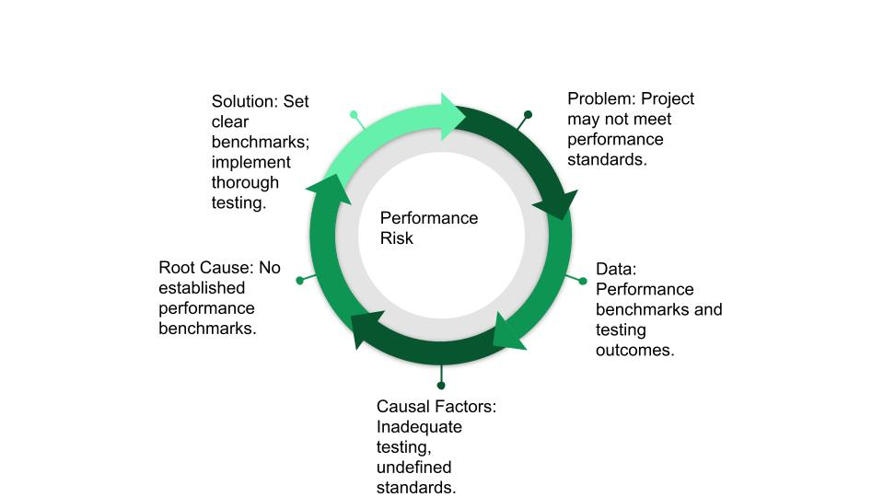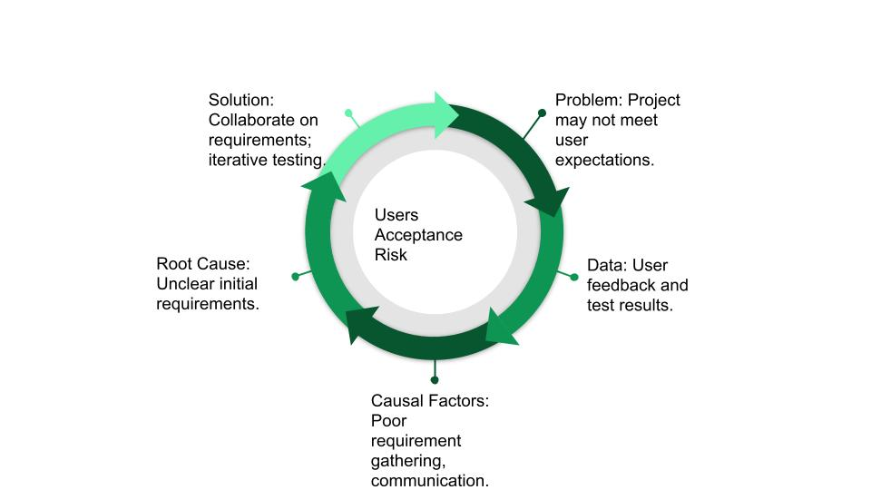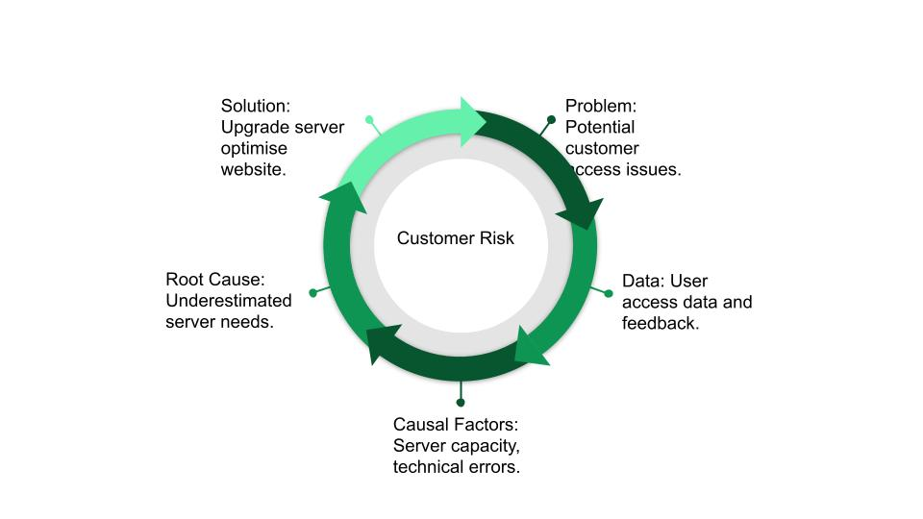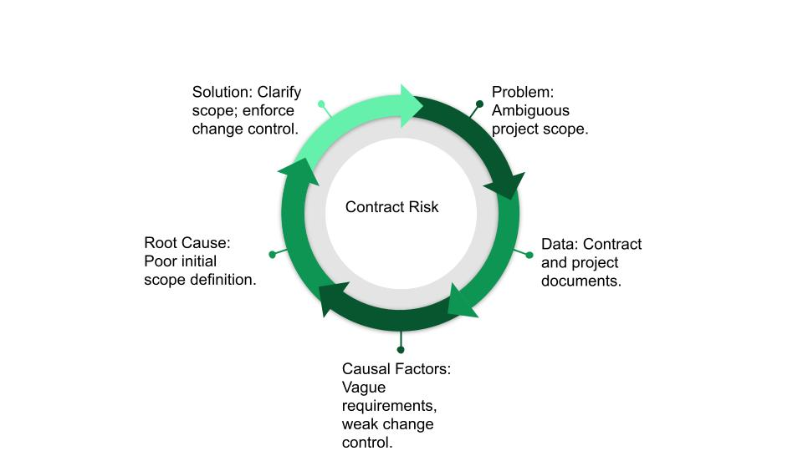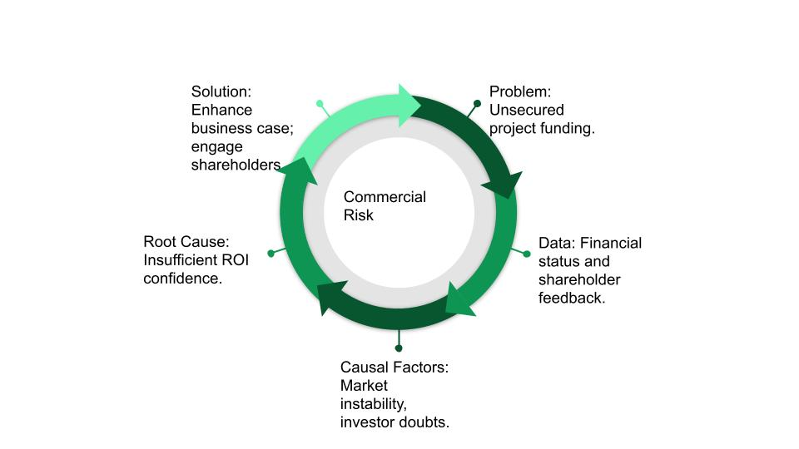

| Level 1 | Level 2 | Level 3 |
| --- | --- | --- |
| E-Commerce Project - Creating the website | Requirements Risk | * The requirements are not clear * Impossible requirements * There is not enough time to complete all the requirements |
|  | Performance Risk | * The website can not handle the number of predicted customers * Does not meet the requirements |
|  | Staffing Risk | * The staff are under qualified * Lots of staff get sick from the flu * Not able to find and train suitable staff in time for the project |
|  |  |  |